IB Computer Sci. Group 14 Name: zenan chen

1. a. a=[0,1]

for i in range (1,5):

a=a+[a[i]+a[i-1] ]

print a

[0,1,1,2,3,5]

b. a=[]

for I in range(4):

b=[ ]

for I in range(3):

b=b+[i+2\*x]

a=a+[b]

print a

[[0,2,4],[1,3,5],[2,4,6],[3,5,7]]

c. a=[1,3,4,2,8]

b=[ ]

for I in range(len(a)-1):

b=b+[a[i+1]-a[i]]

print b

[2,1,-2,6]

2)

Import random S=0

For I in range(100):

S=s+random.uniform(0,1)

Print s

b.

a=[n,n+1,n+2,n+3,n+4,n+5......]

print sum(a)/len(a)

c. Import random

xx=[]

for I in range(10):

r=xx+[range(10)]

b=range(10)

t=3.0

for j in range(10):

 for i in range(10):

if random.uniform(0,10)<t:

r[i][j]=1

else:

r[i][j]=0

print r

3) from graphics import \*

win=GraphWin()

win.setCoords(-10,-10,10,10)

for i in range(1,6):

circ=Circle(Point(i,i),(2\*\*0.5) \* i) rec=Rectangle(Point(-i,-i),Point(0,0))

t = Text(Point(-5,9-i),"yo")

circ.draw(win)

 rec.draw(win)

t.draw(win)

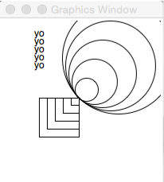

a. Convert the base5 number 342 to base10 base10 b. Convert the binary number 1010001 to base 10. c. Convert the base10 number 532 to base5.

1.97 2.81 3.4112